
Commission for Accessibility
Meeting Minutes
April 13, 2026
Via Webinar

Webinar online access:
5:06 PM CALL TO ORDER

In Attendance: Debbie Prieger, Debra Francseshini, Divya Dorairrajan, Tony Phillips, Christine Santori, Don Ciota.

Link to recorded minutes of this meeting:

https://us02web.zoom.us/rec/share/5Bau62Vh7oSWA1U235V5v_HFJ0nlh_hyxXxPbHYF1AMxc90s-Ab8AmI5yNsGKUi-.1XD2q5qhtngGbutu?startTime=1773090037000
Passcode: ynW#@3vG

N.B. There were two motions made during this session.

APPROVAL OF MINUTES: March 9, 2026

MOTION 1: To approve minutes from February 12, 2026.
Motion made by Divya, second by Debbie
Approved Unanimously.

PUBLIC COMMENT
NONE.



Commission for Accessibility
Don Ciota, Chairman

The Foundation of Societal Care for the Disabled

The "Golden Rule"—the principle of treating others as you would like to be treated—is a universal ethical concept with
roots stretching back thousands of years across nearly every major civilization and religion. While the term "Golden Rule" itself only gained widespread use in the 17th century through Anglican theologians, the concept of reciprocal morality is far older.
Earliest Recorded Origins
- Ancient Egypt (c. 2040–1650 BCE): The Tale of the Eloquent Peasant advises reciprocity, linked to the goddess Ma'at.
- Ancient China (c. 500 BCE): Confucius taught the "Silver Rule" (negative form): "What you do not wish for yourself, do not do to others".
- Ancient Greece (c. 600–300 BCE): Philosophers like Thales and Isocrates emphasized avoiding actions that anger you when done by others.
Religious Formulations
The concept is a central pillar in the texts and traditions of major world religions:
- Judaism: Leviticus 19:18 urges, "Love your neighbor as yourself," while Rabbi Hillel (1st century BCE) famously summarized the Torah through the negative form of the rule.
- Christianity: Jesus stated the rule in its positive form in Matthew 7:12: "do to others what you would have them do to you".
- Hinduism & Buddhism: Both traditions emphasize avoiding actions that cause pain or harm to others.
- Islam: The Hadith emphasizes wishing for your brother what you wish for yourself.

Tale of the Eloquent Peasant
(Ancient Egyptian: Sekhti-nefer-medu) is a celebrated Middle Kingdom literary work (c. 1850 BCE) often cited as the earliest recorded precursor to the Golden Rule.

The Story
The plot follows a peasant named Khun-Anup who is traveling to market when he is tricked and robbed by a corrupt official named Nemtynakht. Seeking justice, Khun-Anup appeals to the High Steward, Rensi.

The High Steward is so impressed by the peasant's "eloquence"—his ability to speak with high-level rhetorical and ethical skill—that he reports it to the Pharaoh. The Pharaoh, wanting to hear more of these beautiful speeches, commands the Steward to delay giving justice while secretly recording every word the peasant says.

Significance: It frames justice not just as a legal outcome, but as a universal principle where authority figures have a moral duty to act toward others with the same fairness they would expect for themselves.

Historic records for medieval societies caring for persons with disabilities?
There are significant historic and archaeological records documenting how medieval societies cared for persons with disabilities. While attitudes were often mixed—ranging from viewing disability as a punishment for sin to seeing it as a sign of divine piety—medieval communities developed structured systems of support through religious institutions, families, and early "hospitals".

Formal Institutions and Shelters
Medieval Europe saw the rise of specialized institutions that provided long-term care for those unable to function in mainstream society:
- Hospitals and Almshouses: Unlike modern medical centers, medieval hospitals like St John's in Canterbury were founded to provide 24-hour long-term care for "cripples," the blind, and "idiots". Almshouses, often called bede-houses, provided food and permanent housing in exchange for residents praying for the founder's soul.
- Leper Houses: Leprosy was a common visible disability. Authorities established isolated leper houses (leprosariums) modeled after monasteries to care for sufferers, though these also served to segregate them from the public.
- Mental Institutions: England's first mental institution, Bethlem Hospital (later known as "Bedlam"), was established in the late Middle Ages to care for those with mental disabilities or "lunacy".
Community and Legal Support
Most people with disabilities lived within their local communities rather than institutions:
- Family and Parish Support: Families typically cared for disabled children, and if a family could not manage, local towns or monasteries often stepped in to provide food and money.
- Legal Protections: In 13th-century England, the King had a formal duty to ensure that "natural fools" (those with learning disabilities) were properly cared for, and their property assets were protected.
- Royal and Guild Alms: Monarchs, like France's Louis IX, granted specific groups (such as the blind) legal rights to beg on city streets for survival. Trade guilds also established early "welfare" homes for their elderly or infirm members who could no longer work.
Technological and Archaeological Evidence
Modern research has uncovered physical proof of specialized care:
- Mobility Aids: Medieval manuscripts depict the use of hand trestles—early versions of walking frames—which allowed individuals with lower-limb disabilities to remain mobile. Archaeological finds also include early magnifying glasses for the visually impaired.
- Surgical Success: Bioarchaeological studies of cemeteries (such as in Lithuania) show remains of individuals who survived traumatic injuries or amputations, indicating they received sophisticated medical care and long-term nursing support during their recovery.
Would you like to explore how specific religious beliefs shaped these care systems, or perhaps see more details on medieval medical treatments for physical impairments?
AI can make mistakes, so double-check responses

- Disability in the Middle Ages
In medieval society, care for persons with disabilities was a complex blend of religious duty, specialized medical practice, and community support. While views were often polarized, the period saw the birth of many foundational care structures.
Religious Beliefs and Care Systems
The Church was the primary architect of medieval disability care, though its theology was deeply paradoxical.

- Mixed Attitudes: Disabilities were sometimes viewed as a punishment for sin or "divine retribution". Conversely, some believed disabled individuals were closer to God, enduring a "purgatory on earth" that would grant them faster entry to heaven.
- Charity as Redemption: The "Economy of Salvation" drove much of the care. Giving alms to the "impoverished and impaired" was considered a Work of Mercy that could reduce a donor's time in Purgatory.
- Miraculous Healing: Religious life often centered on saints' shrines, where those with impairments traveled as pilgrims seeking "miraculous cures". For example, the Shrine of St. Dymphna in Gheel became a famed center for the community-based care of those with mental disabilities.
- Canon Law Restrictions: Despite the charitable focus, Canon Law often barred men with visible "deformities" from the priesthood, fearing their appearance might distract the laity during the mass.
Medical Treatments and Impairments
Medieval medicine for disabilities was more sophisticated than popular myths suggest, relying on a mix of ancient Greek texts and practical observation.
Wikipedia +1

- The Four Humours: Treatment often aimed to balance the four bodily fluids (blood, phlegm, yellow bile, and black bile). For instance, melancholia (often related to modern depression or schizophrenia) was treated by attempting to purge "excess black bile" through diet or herbal remedies.
- Surgical Interventions: Archaeological evidence from sites like Lithuania and Poulton (Cheshire) has uncovered skeletons with healed amputations, proving that patients could survive major surgery and receive long-term nursing care for years afterward.
- Assistive Technologies:
  - Prosthetics: Skeletons have been found with iron rings or wooden attachments—early prosthetic feet and hands—designed for functional use.
  - Mobility Aids: Medieval mobility aids included hand trestles for crawling or walking and early crutches.
  - Sensory Supports: Some blind individuals utilized service dogs, and early versions of magnifying glasses existed for the visually impaired.
- Herbal Remedies: Monasteries maintained extensive herb gardens to create salves. Following the Doctrine of Signatures, they believed God marked plants with their purpose; for example, skullcap seeds (which look like tiny skulls) were used to treat chronic headaches.

MOTION II: To add to this agenda a discussion of upcoming events.
Motion by Deb, Seconded by Divya
APPROVED UNANIMOUSLY
Sunday, April 19, 2026 at 2-4:00 PM at Yannity Gym. Second Annual Non-Profit Fair hosted by the Ridgefield Newcomer’s Club with a registration fee of $30.00.
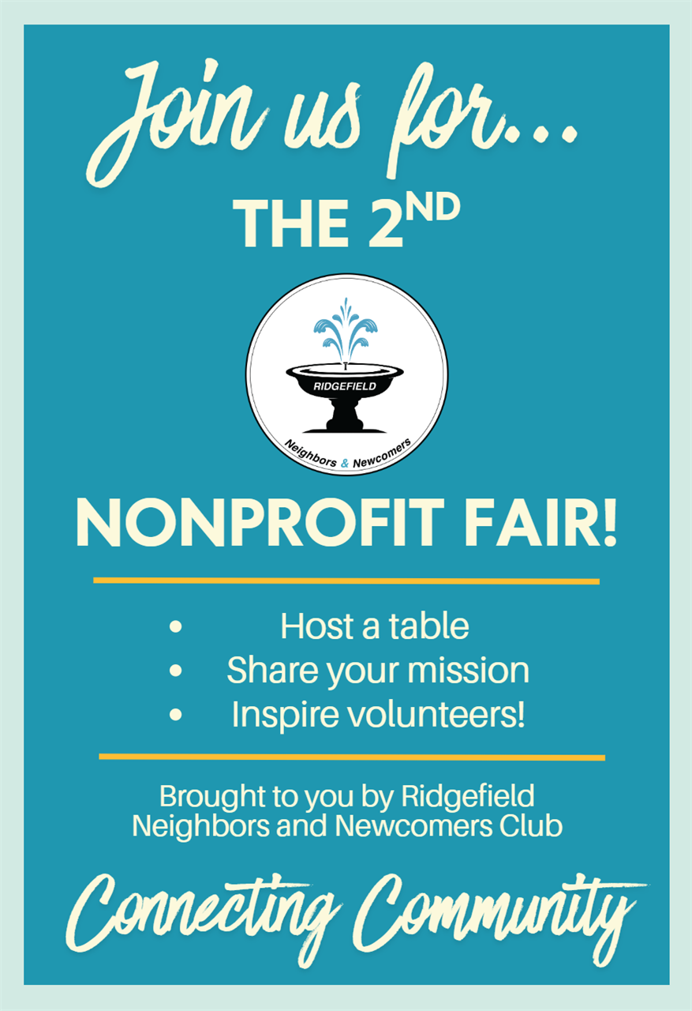
Ridgefield Memorial Day Parade.
Deb has registered our participation in this event.
QR Code for Commission for Accessibility:

QR is attached as a PNG file.
https://bit.ly/4tIYu6H

6:10PM ADJOURN

Minutes by Don Ciota, Chairman

2026 Meeting Dates:

May 11 June 8 July --- Aug --- Sept 14
Oct 19 Nov 9 Dec 7

